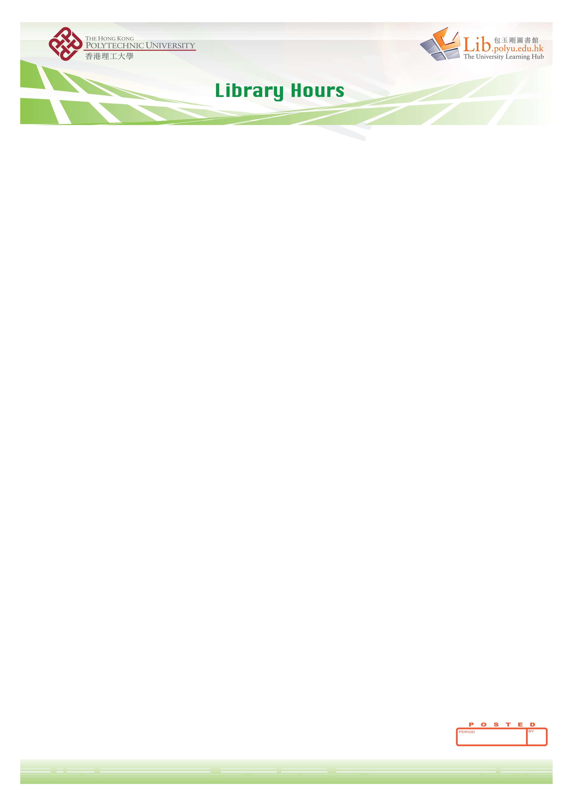
Library Opening Hours for 2011/2012
 | Term Time  1 Sep 2011 – 25 Nov 2011  21 Dec 2011 – 6 Apr 2012  28 Apr 2012 – 29 Jun 2012 |  | Revision & Examination Period  26 Nov 2011 – 20 Dec 2011  7 Apr 2012 – 27 Apr 2012  30 Jun 2012 – 7 Jul 2012
Mon − Fri | 8:30 am – 11:00 pm |  | 8:30 am – 11:00 pm
Sat | 8:30 am – 11:00 pm¹ |  | 8:30 am – 11:00 pm
Sun | 12:00 pm – 10:00 pm^{2,3} |  | 8:30 am – 11:00 pm
Public Holidays* | Closed⁴ |  | 8:30 am – 11:00 pm⁵
- The Library will open from 8:30am to 6:00pm on Christmas Eve (24 December 2011, Sat), New Year’s Eve (31 December 2011, Sat).
- The Library will open from 10:00am to 10:00pm on the PolyU InfoDay (18 September 2011, Sun)
- The Library will open from 12:00 noon – 7pm on the day preceding Lunar New Year (22 January 2012, Sun).
- The Library will close on 25 December 2011 (Sun) to 27 December 2011 (Tue) for the Christmas holidays.
- The Library will open from 8:30am to 11:00 pm on the day following Good Friday (7 April 2012, Sat), Easter Sunday (8 April 2012, Sun), Easter Monday (9 April 2012, Mon), HKSAR Establishment Day (1 July 2012, Sun), and the day following the HKSAR Establishment Day (2 July 2012, Mon).
Summer
8 Jul – 31 Aug 2012
Mon – Fri |  | 8:30 am − 10:00 pm
Sat |  | 8:30 am − 7:00 pm
Sun/Public Holidays |  | Closed

*Library Hours for General Holidays, 2011/2012

Date | General Holiday | LIB Hours
13 Sep 2011 (Tue) | The day following Mid-Autumn Festival | Closed
18 Sep 2011 (Sun) | PolyU InfoDay | 10:00am – 10:00pm
1 Oct 2011 (Sat) | National Day | Closed
5 Oct 2011 (Wed) | Chung Yeung Festival | Closed
24 Dec 2011 (Sat) | Christmas Eve | 8:30am – 6:00pm
25 Dec 2011 (Sun) | Christmas Day | Closed
26 Dec 2011 (Mon) | The first weekday after Christmas Day | Closed
27 Dec 2011 (Tue) | The second weekday after Christmas Day | Closed
31 Dec 2011 (Sat) | New Year’s Eve | 8:30am – 6:00pm
1 Jan 2012 (Sun) | The first day of January | 12:00noon – 10:00 pm
2 Jan 2012 (Mon) | The day following the first day of January | Closed
22 Jan 2012 (Sun) | The day preceding Lunar New Year | 12:00noon – 7:00pm
23 Jan 2012 (Mon) | Lunar New Year’s Day | Closed
24 Jan 2012 (Tue) | The second day of Lunar New Year | Closed
25 Jan 2012 (Wed) | The third day of Lunar New Year | Closed
4 Apr 2012 (Wed) | Ching Ming Festival | Closed
6 Apr 2012 (Fri) | Good Friday | Closed
7 Apr 2012 (Sat) | The day following Good Friday | 8:30am – 11:00pm
8 Apr 2012 (Sun) | Easter Sunday | 8:30am – 11:00pm
9 Apr 2012 (Mon) | Easter Monday | 8:30am – 11:00pm
28 Apr 2012 (Sat) | The Buddha’s Birthday | Closed
1 May 2012 (Tue) | Labour Day | Closed
23 Jun 2012 (Sat) | Tuen Ng Festival | Closed
1 Jul 2012 (Sun) | HKSAR Establishment Day | 8:30 am – 11:00 pm
2 Jul 2012 (Mon) | The day following the HKSAR Establishment Day | 8:30 am – 11:00 pm

31/11/2008 - 15/03/2009
ALL

